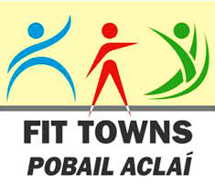
Fit Town 2017 (13th Feb – 27th March)- ‘Sign Up’ Form

1. Name of Lead Club/Organisation:

2. Project Lead (s): Name(s):

Phone(s):

eMail:

3. Are you collaborating with any other Clubs/Organisations/Groups? Yes / No

Name of Club/Organisation/Groups you are collaborating with?

4. Target Group (Please tick as appropriate)

Women & Girls
People with Disabilities
Older Adults (over 55yrs)
Unemployed
Disadvantaged Groups
Travellers

Other Relevant Groups
Older Men
Children
Families
Other ________________________________________________
5. Programme Details

Programme Goal (e.g. run 5k, dance 10 steps, swim a width… etc)

Outline below a short description of what your programme is about and how it will benefit the target group/wider community;

Proposed Schedule (Between … Jan – Feb):

PROPOSED SCHEDULE please provide SPECIFIC DATES, DAYS and TIMES e.g. each Tuesday and Thursday evenings @ 7pm. All events must be scheduled between 13th February and 27th March 2017. The format you decide will depend on the goal you set - you may require weekly classes, biweekly, one off workshop or other:

VENUE/LOCATION OF EVENT:

Signed: Date:

Completed forms to be returned by close of business Monday 19th December.

For further information email fitballinasloe@gmail.com 087-6261709
Fit Town Team: Marion Ruane, Noel Mannion, Lyn Donnelly, Student Reps.

