Ballinasloe Town Team Project
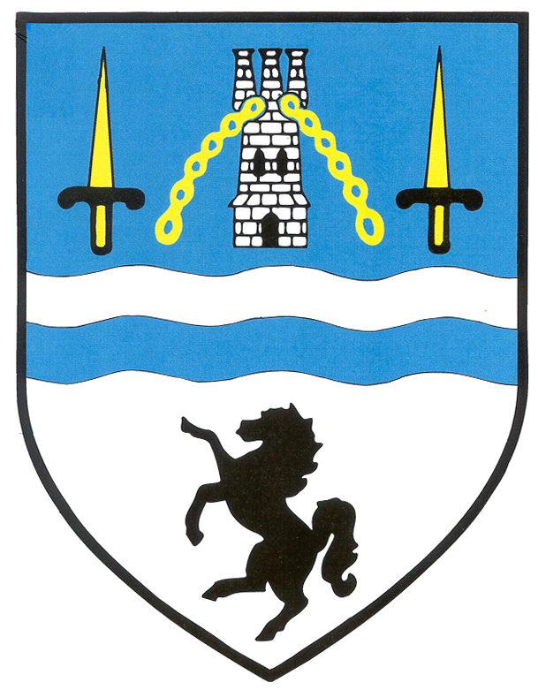
Ballinasloe People of the Year Awards 2015
In association with


Nomination Form

Supported by Shearwater Hotel & Ballinasloe Town Team
Nomination Form
Please Read the Information Sheet Carefully Before Completing this Form
Closing Date: Friday October 9th 2015

Please type your answers
Please tick the Category you are nominating
  Social & Community Support Award
  Arts, Culture and Heritage Award
  Sports and Recreation Award
  Young Person’s Award
  Civic Pride Award
  Community Group Special Recognition Award
  Hall of Fame Award
Section A: Details of the Group or Person being Nominated
Name of Group or Person:

Contact Details for Group or Person: (name, address, email & mobile)

Please give details of the nominee and their activities within the Community to date.

Please state why the Group or Person should win the above mentioned category.

Give examples of their achievements and contributions relevant to the category.

Please describe the difference the Group or Person has made to the Community

Section B: Details of Persons Nominating the Group or Person( Each nomination requires a proposer and a seconder to validate the nomination)
Proposer Name:
Address:
Email:
Mobile No:
Seconder Name:
Address:
Email:
Mobile No:
(You may include any additional information with this form to help inform the judges.)
Please email this form and any additional information to:
Lyn Donnelly - info@ballinasloeenterprisecentre.ie
or
you can post or hand deliver to Ballinasloe Enterprise Centre, Creagh, Ballinasloe, Co. Galway

On or before 5pm on Friday October 9th 2015

If you have any queries you can phone Lyn on Tel: (090) 9646516

This Nomination Form and information can be downloaded from www.ballinasloe.ie

