IMPORTANT
Are you aware, there is another application with Galway County Council for a: Permit To Operate A Major Waste Facility in Ballinasloe – the waste operator has purchased over 90(ninety) acres,
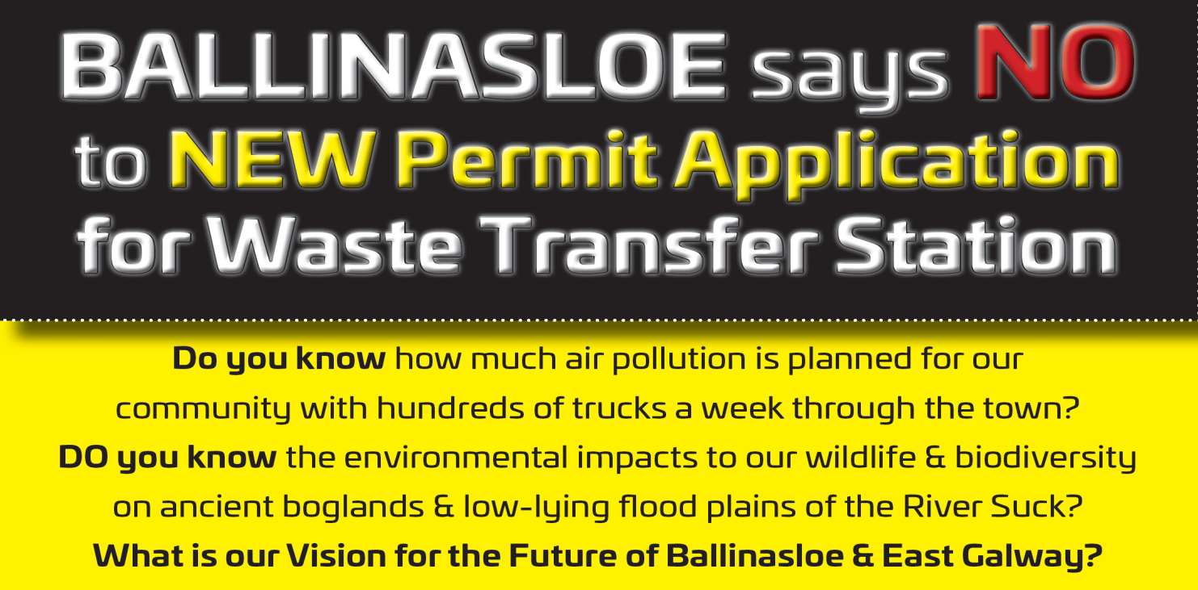
Act now. Closing Date for Submissions is Jan. 15th. 2021. Email or Post an Objection Or use the Template attached
All members of the household, including children can submit an objection
OBJECTION – TO INCLUDE…
1) The name and Address of person making the observation
3) Quote Licence application’s reference number. Code WFP-G-20-0009-01
EMAIL TO Environment@galwaycoco.ie CC TO Ballinasloesaysno@gmail.com
Post To; Environment Section, Galway County Council, Prospect Hill, Galway.H91 H6KX

Reasons for Objections
  - ROAD SAFETY: with 30 tonne trucks travelling right through the heart of the town and impacting on up to 6,500 road users, pedestrians, cyclists, drivers.
  - HEALTH IMPACTS: Air Pollution. Diesel trucks(Particulate matter) in a built up area – impact to air quality and the damage to the environment
  - Leachate into drinking water supply
  - ENVIRONMENTAL IMPACTS: Proposed site in low-lying flood plains of the River Suck Callows an SPA (Special Protection Area - EU Directive). Climate change and proposed rewetting of bogs lead to higher flood levels.
  - Unique biodiversity in our bogland areas with special protection of wildlife in the River Suck Callows SPA.
  - High Court Orders 1999 and 2018

  - EMAIL AN OBJECTION TO…
To: Environment@galwaycoco.ie & Cc: ballinasloesaysno@gmail.com OR Drop it into a Box in Local Shops (Dolans Garage , Creagh. EuroSpar StMichaels SQ, Corrib Oil Brackernagh. Supervalu Brackernagh)

To whom it may concern,
(REQUIRED) Name:
(REQUIRED) Address:

I STRONGLY object to the Permit To Operate a Waste Transfer Station in Ballinasloe, reference no: WFP-G-20-0009-01

My objection is based on the following issues;
- The impact on road safety arising from heavy duty trucks hauling waste through the main streets of the town and increasing the risk of accidents with drivers, cyclists & pedestrians. The proposed route passes Portiuncula Hospital, two Secondary schools, the Health Centre, the soccer pitch, shops, children’s playgrounds and many homes and residential areas. The increased risk of accidents and even fatalities is completely unacceptable.
- Health Impacts - this site is located within 2 kilometres of the town centre and a population of 6,662 people in Ballinasloe brining huge amounts of air pollution in a built up area as well as potential impacts with leachate into drinking water supplies.
- Environmental Impacts – proposed site is in the low-lying flood plains of the River Suck Callows with rising flood levels due to climate change and rewetting of bogs. Also impact to unique biodiversity and wildlife as this impacts on 3 Special Protected Areas with European status.
- Future of the Ballinasloe area
  - Strong contender to bring the Galway to Athlone Cycleway through Ballinasloe
  - Destruction of the town centre with heavy vehicles subsequent to multi-million euro investment in street enhancement project. Impact to future investment to Ballinasloe and the reputation of the town to attract people to live and work here.
  - Damage to the road infrastructure with the high frequency and volume of heavy traffic and Ballinasloe does not have the roads infrastructure to manage this.
  - Increased congestion of roads and the knock on effects to emergency services and school traffic. A greater risk of road traffic collisions with road users along the unsuitable narrow urban and rural roadways approaching the site.

- High Court Orders 1999 and 2018 – prohibiting this type of waste facility in this location.

I hope my objection and the objections of others in relation to the review of this waste facility permit will be given due consideration by Galway County Council. This is not an appropriate location for any type of waste facility where 10 tonne, 15 tonne and 30 tonne trucks will be brought through the centre of the second largest residential and urban area outside of Galway city.
SIGNED _________________________________________________

Please enter own comments here -how would this affect you and your family?
__________________________________________________________________________________________________________________________________________________________________________________________________________________________________________________________________________________________________________________________________________________________________________________________________________

